
Five River City
Summer Code Camp 2021

Proudly presented by Northwoods Software Testing Services

June 21st-25th
10:00-3:00
Learn to code while making new friends!
Free of charge!
Laptops will be provided

Lunch* included

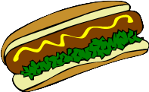
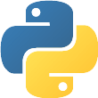
Make games!
Solve puzzles!
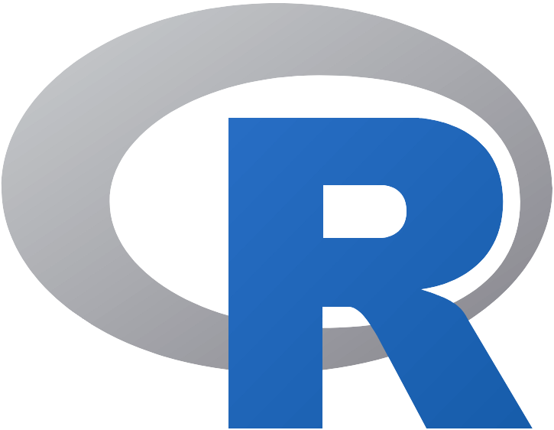

C⁺⁺
Python

FUN!!!

ALL are welcome!
No previous computer programming experience required!
Hamburgers!

* Your choice of hamburger, corn dog, or vegan hot dog and one (1) snack
(vegan) Hot Dogs!

Please fill out and return no later than May 25th
Name:
School:
Grade:
List three (3) programming languages that you are interested in:

Parent or legal guardian’s contact number:
Parent or legal guardian’s signature:

